**456/2**

**MATHEMATICS**

**Paper 2**

**MAY 2016**

**2 $\frac{1}{2}$ hours**

**UGANDA CERTIFICATE OF EDUCATION**

**JOINT EXAMINATIONS 2016**

**MATHEMATICS**

**Paper 2**

**2 hours 30 minutes**

**INSTRUCTIONS TO CANDIDATES**

Answer **all** questions in section **A**, and any ***five*** questions in section **B**

All necessary calculations must be done in the answer booklets provided. Therefore no paper should be given for rough work

Graph paper(s) is(are) provided.

Silent, non programmable scientific calculators and mathematical tables with a list of formulae may be used.

**Turn over**

SECTION A (40 marks)

1. Without using tables or calculator, evaluate. (04 marks)

2. Find the equation of a line passing through the point  and is perpendicular to the line whose equation is . (04 marks)

3. Given that  and  find the value of . (04 marks)

3. Simplify: . (04 marks)

4. In a class of 15 students, 7 like Mathematics, 9 like English and 2 like neither of the subjects. Find the number of students who like both Mathematics and English. (04 marks)

5. The prince of a house valued at 15 million shillings increased by 25% after the first year and decreased by 10% in the second year. Find the value of the house after a period of two years. (04 marks)

6. Given that  and , find , hence find  when . (04 marks)

7. Express  in the form  and write down the values of ,  and . (04 marks)

8. Given that  and , find . Hence find  (04 marks)

9. A rectangle 6cm long and 5cm wide is enlarged so that its area becomes270 cm2 . Find the linear scale factor of enlargement. (04 marks)

10. R is a point which is 13 units from the origin. If the x- coordinate is 12,find the possible values of the y-coordinate. (04 marks)

SECTION B (60 marks)

11. In a certain country, the following allowances are given to employees.

|  |  |
| --- | --- |
| ALLOWANCE | AMOUNT |
| Marriage | 10% of monthly income |
| Single | 15% of monthly income |
| Biological child above 10years but below 20 years | Shs. 20,000 |
| Biological child who is 10years or below | Shs. 30,000 |
| Medical allowance | of monthly income |
| Transport | Shs. 4,000 per day |
| Rent | Shs 200,000 per month |

James is married with 3 children, 2 below 10 years of age and the other is 14 years old.

Andrew is single but has two dependants aged 11 years and 15 years respectively. Both earn a gross monthly salary of shs 1,600,000. The income structure is given below.

|  |  |
| --- | --- |
|  | Tax rate(%) |
| 1 – 200,000 | 10 |
| 200,001 – 500,000 | 15 |
| Above 500,000 | 20 |

i) Calculate the taxable income for both James and Andrew.

ii) Calculate the total amount of tax paid by both men. (12 marks)

12. All the 25 students of a class in a certain school do atleast one of the optional subjects German (G), French (F) and Wood work (W). Given that 15 take German, 11 take French, 5 take Wood work and French, and 6 take Wood work and German only. Also n(F∩WI∩GI) = n(F∩G∩WI) and 2 take all the three subjects,

1. Draw a Venn diagram to show this information.
2. find the number of students who take
3. Wood work
4. German only
5. If a student is picked at random from the class, find the probability that the student takes just one of these subjects. (12 marks)

13. Given that  and ,

i) find  and . (4 marks)

ii) obtain expressions for  and . (4 marks)

iii) Solve for  if . (4 marks)

14. In the figure below, $\overline{PQ}$: $\overline{PT}$ = 4 : 1, 2 $\vec{PS}$ = $\vec{PY}$, $\overline{RS}$: $\overline{RT}$ = 2 : 3,

$\vec{PT}$ = 3**a** and $\overline{PR}$ = 3**b**.

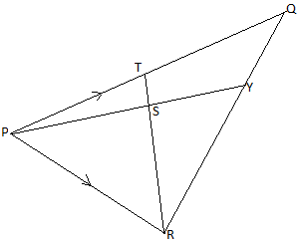

1. Express in terms of **a** and **b**
2. $\vec{RS}$ ii) $\vec{PY}$ iii) $\vec{RQ}$.
3. Find the ratio of $\overline{RY}$ to $\overline{RQ}$. (12 marks)

15a) If p varies jointly as q and r squared, and  when and , find p when  and . (4 marks)

b) The following notice was advertised by Peter Educational consultants.

|  |
| --- |
| PETER EDUCATION CONSULTANCY  This is to inform our esteemed customers to note that with effect from 3rd June 2016, the holiday package payments will be as follows:   1. A fixed consultancy fee. 2. A charge for each holiday package bought. |

In July, Allen bought 50 copies of holiday packages and paid shs 20,000. In July, Allen al so bought 30 copies of the packages and paid shs 16,000.

i) Find the cost equation.

ii) How many copies would Allen get if she paid shs 58,000? (8 marks)

16. The figure below shows a net of a pyramid.

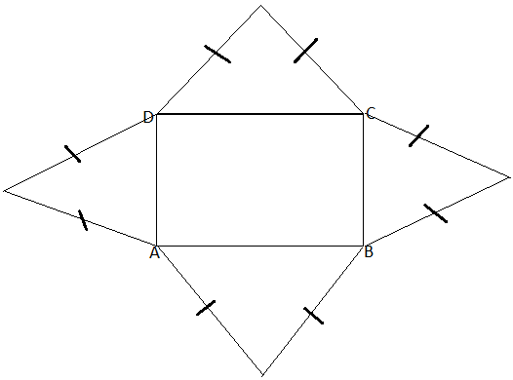

If V is the vertex of the pyramid VABCD with a rectangular base ABCD and triangles of slant sides with  and .

1. Draw a right pyramid showing clearly points VABCD, find the height of the pyramid. (5 marks)
2. Find the area of VAB. (3 marks)
3. Find the angle between:
4. Edge VA and the base. (2 marks)
5. Face VAB and the base. (2 marks)

17. Mbarara is about  away from Masaka. A bus leaves Masaka for Mbarara at  travelling at a steady speed of . A taxi leaves Mbarara an hour later at a speed of  but gets a flat tire after travelling for . The mechanical problem was fixed after and then the taxi arrived at 1:45pm

Draw on the same axes, the distance – time graphs showing the journey of the bus and taxi. (Use scales of and ).

Determine:

i) the time and distance from Masaka when the taxi over takes the bus.

ii) state the times when the two vehicles arrive at Mbale.

iii) differences in the times of arrival of the two vehicles.

**END**